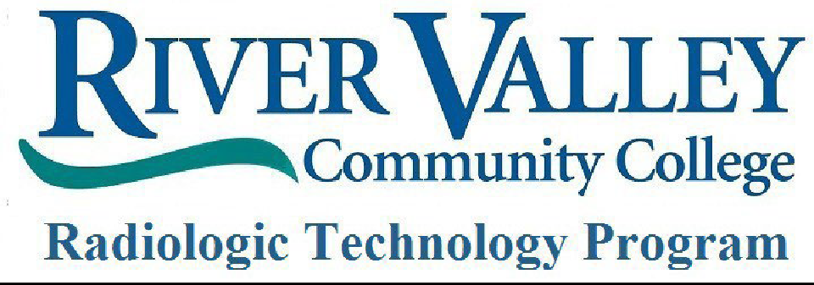

4-8 - Hour Radiology Observation Requirement
Instructions- prospective Rad Tech students should select an observation site of their preference (may be at another site not listed below) and email and/or call the site to schedule an observation. Observers should be aware that sites may not be able to accommodate an observer for weeks to months from the initial observation request. Sites may require immunizations, policy forms, or other site-specific requirements to participate, prior to conducting in an observation at their site.
Students should represent themselves professionally by wearing business casual clothing during the observation and by bringing a copy of the observation form to the day of the scheduled observation to be completed by the prospective student and designated employee.

RVCC’s Rad Tec Program Affiliated Sites Contact Information:

Brattleboro Memorial Hospital
Brattleboro, VT 802-275-3634
Radiology Dept: Christina Aiken- caiken@bmhvt.org

Dartmouth Health, Lebanon campus (formerly DHMC)
Lebanon, NH 603-653-3299
Contacts: WRI team
https://dhwri.org/student-observation-and-practicum-opportunities/ Bethany LaHaye- Bethany.M.LaHaye@hitchcock.org
Hollyann Cramer- Hollyann.B.Cramer@hitchcock.org Bailey Pitkin- Bailey.M.Pitkin@hitchcock.org

Springfield Hospital
Springfield, VT 802-885-2151
Contact: Hayley Druschel Hdruschel@springfieldhospital.org

Valley Regional Hospital
Claremont, NH 603-542-7771
Contacts: Megan Shanks (HR) and Jessica Ball (Radiology) Emails: Megan.Shanks@VRH.org and Jessica.Ball@VRH.org

Northeastern Vermont Regional Hospital
St. Johnsbury, VT 802-748-7426
Contacts: Patricia Forest (Human Resources) and Gretchen Renaud (Radiology Manager) Emails: P.forest@nvrh.org and g.renaud@nvrh.org

Cheshire Medical Center- Dartmouth Health, Keene
Keene, NH 603-354-5454
Contacts: Ian Burke, Education Coordinator and Abby May, Technologist iburke@cheshire-med.com and amay@cheshire-med.com

Monadnock Community Hospital
Peterborough, NH 603-924-7191
Contacts: Mike Greenough, Education Coordinator and Julia Swett, Technologist Michael.Greenough@mchmail.org and Julia.Swett@mchmail.org

North Country Hospital
Newport, VT 802-334-7331
Contacts: Susan Maxwell, Director of Radiology and Kathleen LaFratta, Executive Assistant smaxwell@nchsi.org and klafratta@nchsi.org

